2021 WIFI
Wireless Connection

Instructions
On Campus
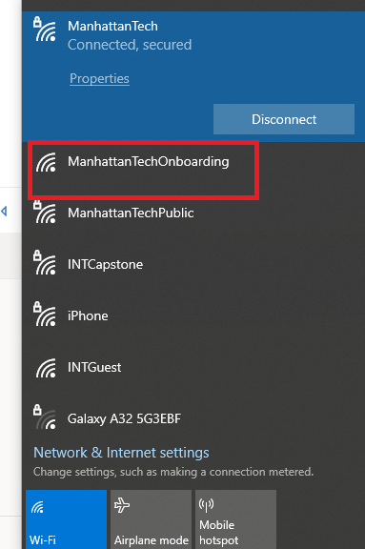 | At HOME browse to “joinwifi.matc.net” and then skip to step 2.  Step 1) Connect to “ManhattanTechOnboarding”
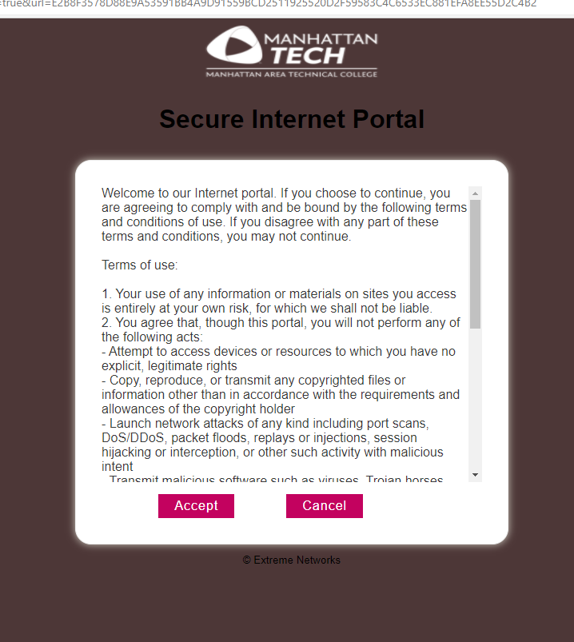 | Once connected you should be redirected to a usage acceptance page. Click “Accept” NOTE*(If this redirection does not occur you can go to “joinwifi.matc.net” to get to the next step.
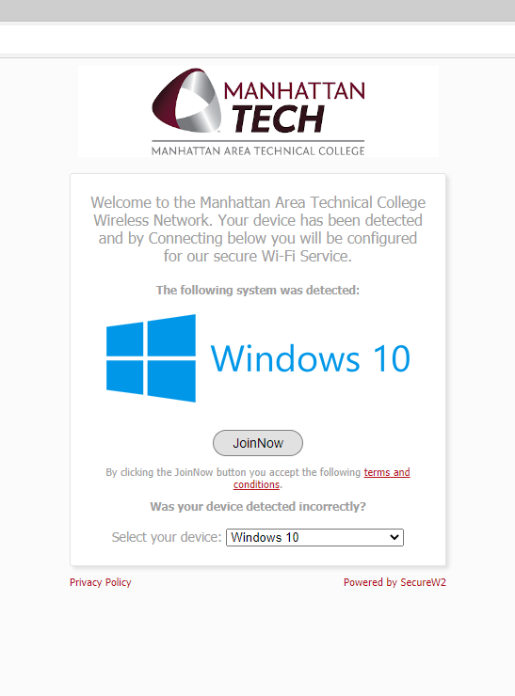 | Step 2) You should then be redirected to the following page where you will download a connection profile to put the wireless certificate on your device.
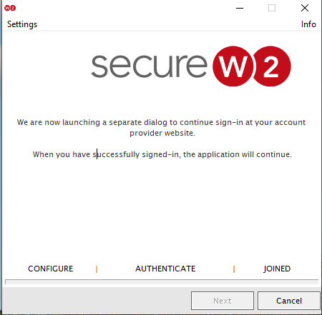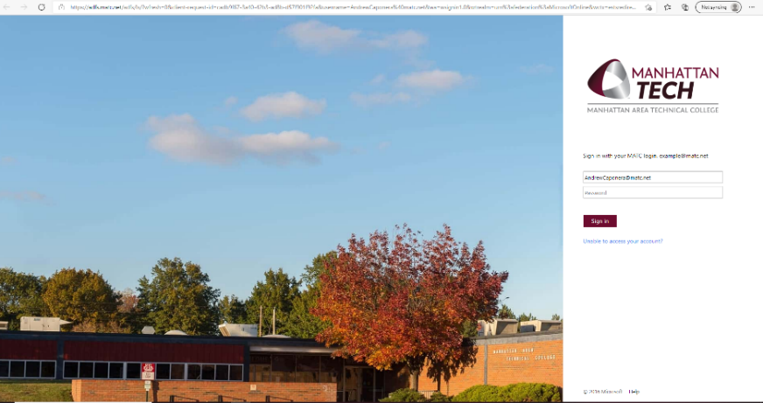
Once you download and run this file “WiFi_Manhattan_Area_Technical_College_Wrapper” it will open the secureW2 program and then ask you to sign in with your MATC credentials. This will then let the program connect to the wifi of “ManhattanTech”

